- Exploring Pedassaare cape

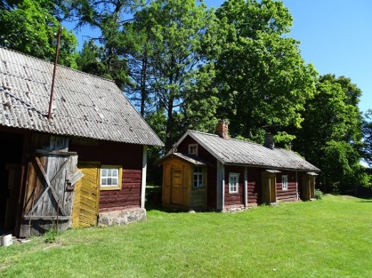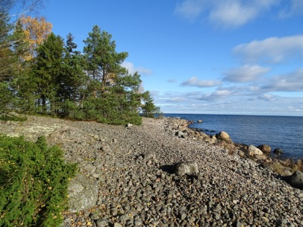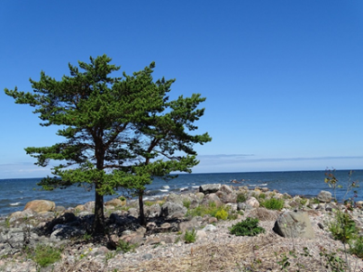

We will explore the unique windy natural landscapes
of Pedassaare cape that are under constant attack
from storms, as well as waves. In Pedassaare, we can see the oldest and thickest coastal
pines in Estonia, firs that crawl along the ground, rubble barrier, and a lot more interesting. Our trip takes us past Soviet border defence facilities, which merge with the surroundings without ruining the integrity of this special place.

As the public transportation to Lahemaa is quite poor, we can pick you up with our car and return you to your accommodation after trip. It takes 3 hours to provide this trip.
Our price of the trip is 100 euros per group (1 – 3 persons).

- Trip to Käsmu peninsula
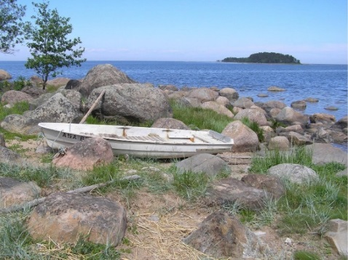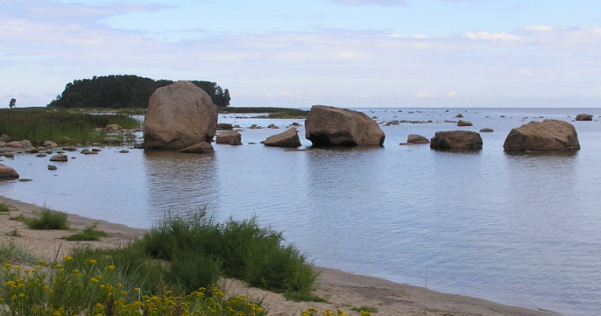
Käsmu peninsula has a rich cultural and natural heritage.
You will see the white houses of the famous ‘Captains’ Village’ and its naval school with a dignified history. Lucky boulders and a statue called Signe that kneels in the graveyard, as well as military heritage from the Soviet times are obligatory sights to visit.
Käsmu peninsula is also a gigantic natural Ice Age park with a unique boulder field and romantic rocks left behind by glacial drift. Lake Käsmu and Eru Bay are places that are unfortunately rarely visited; here, the peninsula that otherwise has a low rocky coastline throws in a surprise sandy beach and high embankment.
As the public transportation to Lahemaa is quite poor, we can pick you up with our car and return you to your accommodation after trip. It takes 3 hours to provide this trip.
Our price of the trip is 100 euros per group (1 – 3 persons).

- Discovering Altja

Altja is a a typical coastal village, with all of its houses stretching along one street. The village has a colourful history and has been restored to its former glory by the Lahemaa National Park. You can see the fishing net sheds which were reconstructed on the basis of old photographs and the memories of the villagers. Altja is also known for its tavern, which offers traditional meals of Estonian coastal people. There is also a village swing and a bonfire site for celebrating St John’s Day.
On the Altja nature and culture historical trail (3 km) we can see the fishing village and the surrounding nature from the shingle beach to the Altja river floodplain.
As the public transportation to Lahemaa is quite poor, we can pick you up with our car and return you to your accommodation after trip. It takes 3 hours to provide this trip.
Our price of the trip is 100 euros per group (1 – 3 persons).

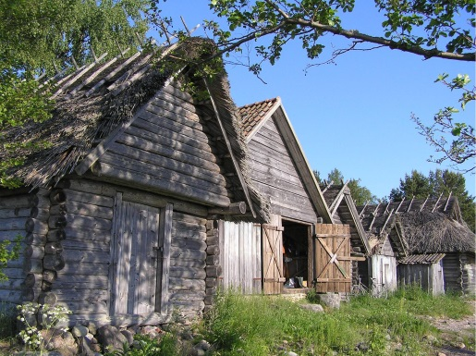

.

- Oandu old-growth forest nature trail and Visitor Centre
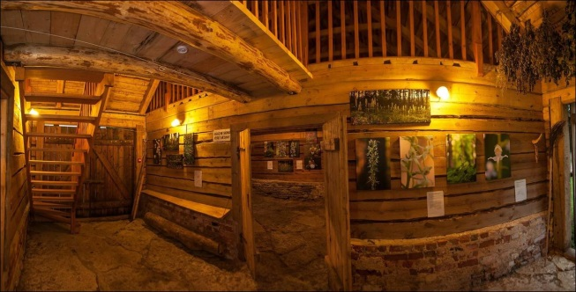
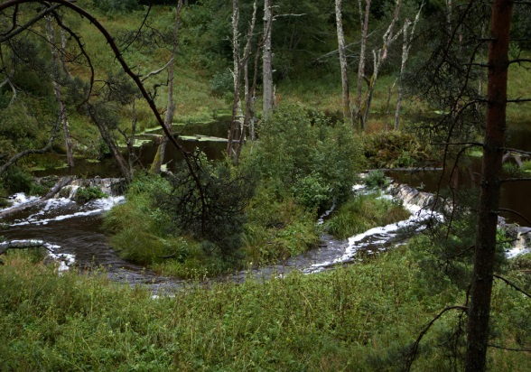
We will walk on the Oandu old-growth forest nature trail (4.7 km). The trail introduces old coastal ridges, the different developmental stages of Florest. On the trail we can see the virgin forest and different forest types, also traces of wild animal activities.
We could also visit the Oandu Visitor Centre in a 150-year-old building, which formerly housed the forest district Office and its outbuildings, the Cone Hut, the hay barn and the old ice cellar. The centre introduces nature, as well as the production and use of forest and timber throughout the ages.
Near is also the Beaver trail (1 km), where we can see traces of beaver activity—beaver dams, lodges constructed along the riverbank and felled trees—can be seen in the deep river valley.
As the public transportation to Lahemaa is quite poor, we can pick you up with our car and return you to your accommodation after trip. It takes 3 hours to provide this trip.
Our price of the trip is 100 euros per group (1 – 3 persons).

- Whole day tour in Lahemaa
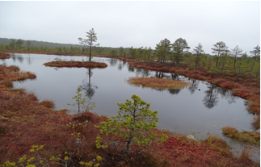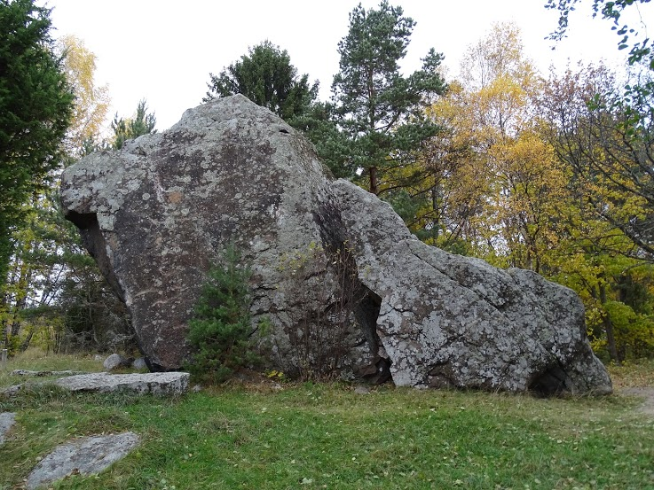
Viru bog the glacial boulder of Jaani-Tooma
If You are interested of seeing more in Lahemaa National Park we suggest a whole day tour. It consists of tour in Viru bog, looking some huge glacial boulders or little waterfalls in forest, visiting our traditional villages near the sea, walking on narrow Cape of Pedassaare, where you can see the sea on two sides of you. You may also have a lunch in some local pub. Whole day trip will take 6 -7 hours. Our price of whole day trip is 25 euros per hour and it will be 150-175 euros all together. It does not include the food.

